Gauge Meter Detection on nuclear plant :  
  
1. Data Collection

2. Data Labelling

3. Importing pre-trained weights from YoloV10

4. Training the model using pre trained weights

5. Model evaluation

6. Inference on Custom data

**Model Comparison btw Yolov9 & Yolov10 :**

|  |  |  |
| --- | --- | --- |
| Models | **Yolov9** | **Yolov10** |
| Datasets | Roboflow | Roboflow |
| No.of.Classes | 5 Classes Start / End / Center / Tip / Background | 5 Classes Max/ Min / Base / Tip / Background |
| No.of.images Train / Val / Test | 7500 / 1000 / 500 | 8500 / 1000 / 300 |
| GPU | Nvidia / Tesla T4 (15GB) | Nvidia / Tesla T4 (15GB) |
| Pre-trained weights | gelan-c.pt | yolov10n.py |
| No.of.Epochs | 25 | 25 |
| Precision / Recall @ epoch 1 | 0.53 / 0.59 | 0.44 / 0.55 |
| Precision / Recall @ epoch 25 | 0.87 / 0.87 | 0.74 / 0.76 |
| mAP @ epoch 1 | 0.592 | 0.482 |
| mAP @ epoch 25 | 0.912 | 0.752 |

Confusion Matrix :   
  
Yolov9 :  
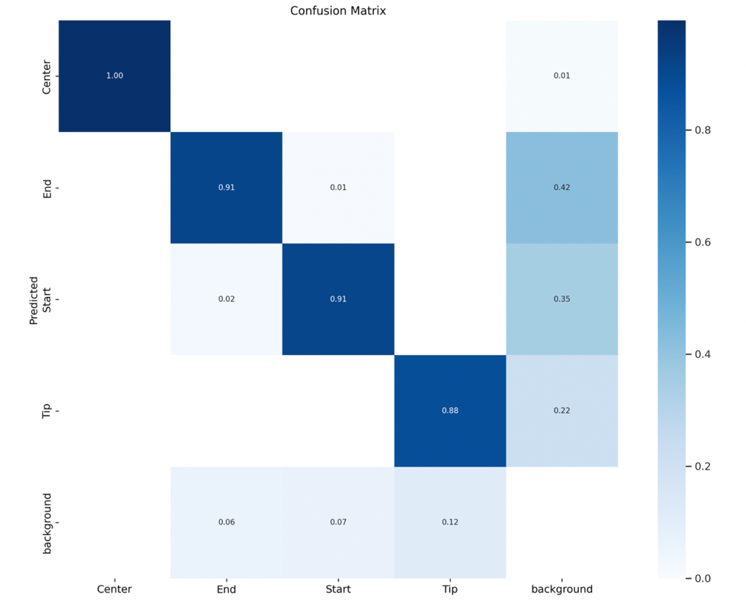

Yolov10 :  
 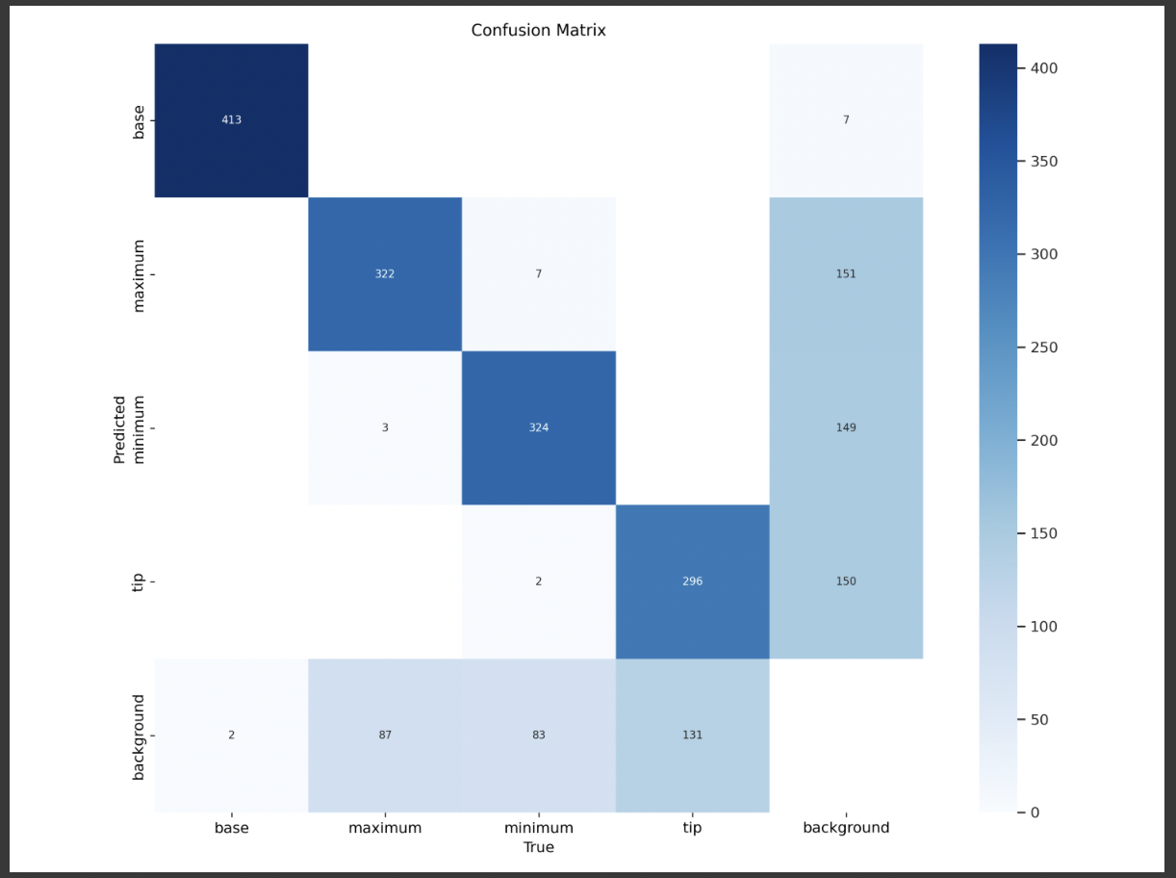  
   
  
  
  
  
Precision/Recall Curve : (Yolov10)

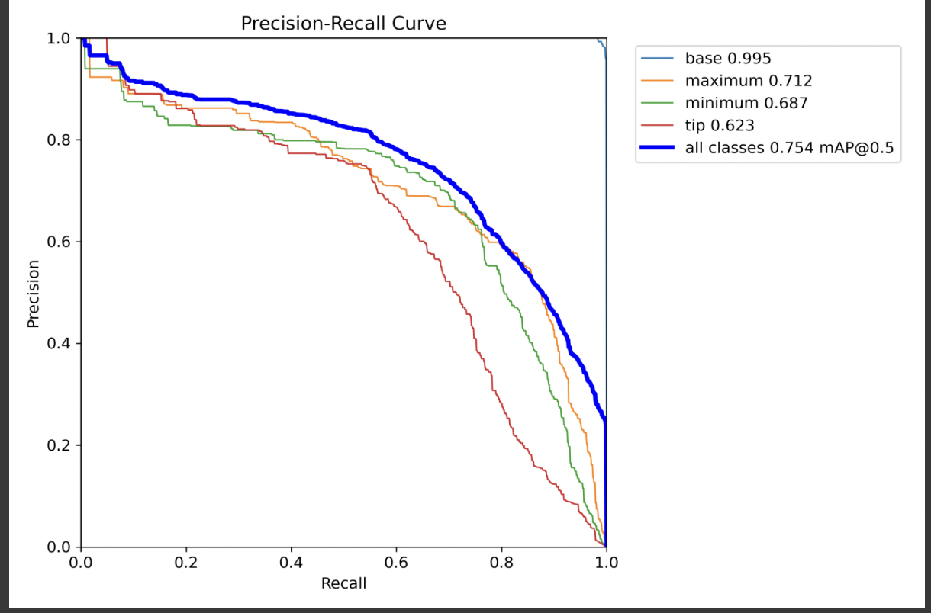  
  
F1-Curve : (Yolov10)  
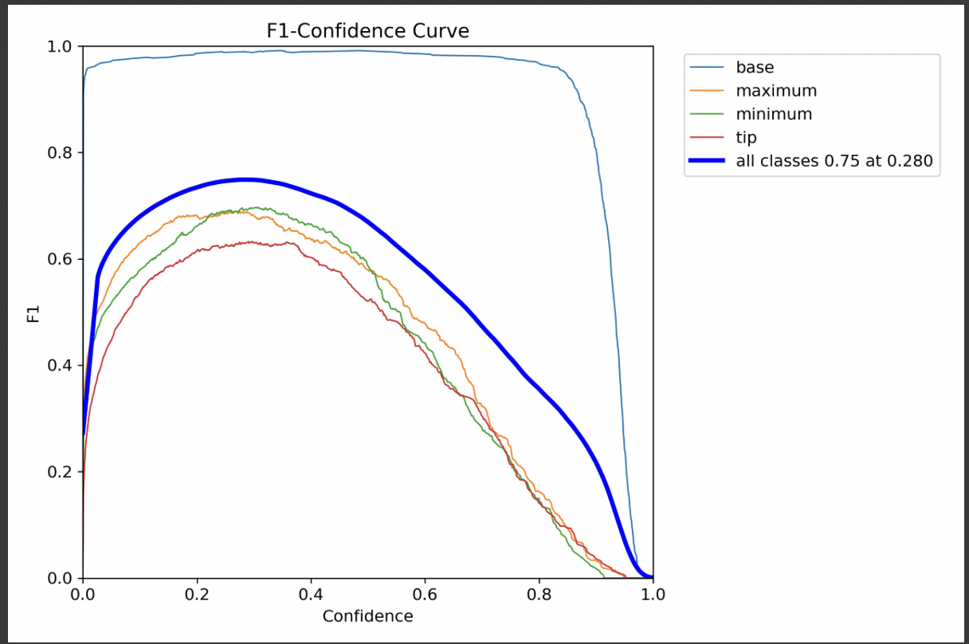  
  
Results :  
  
Yolov9 :  
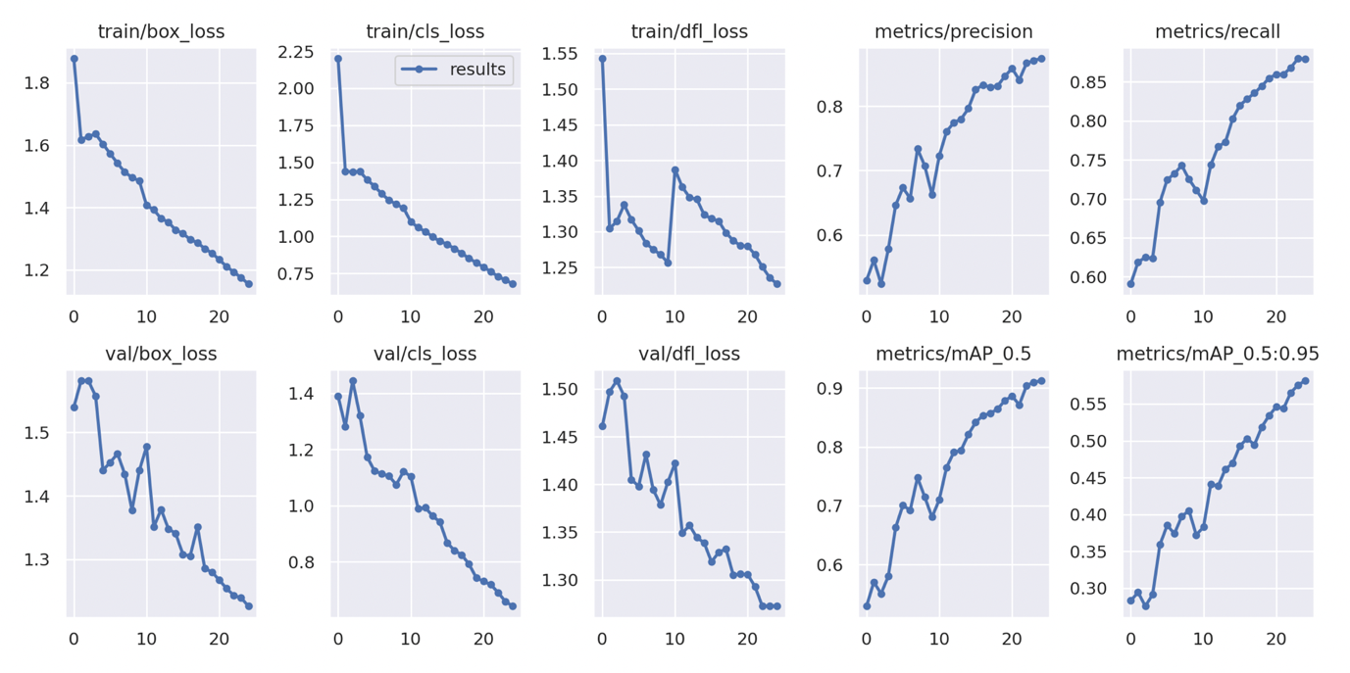

Yolov10 :  
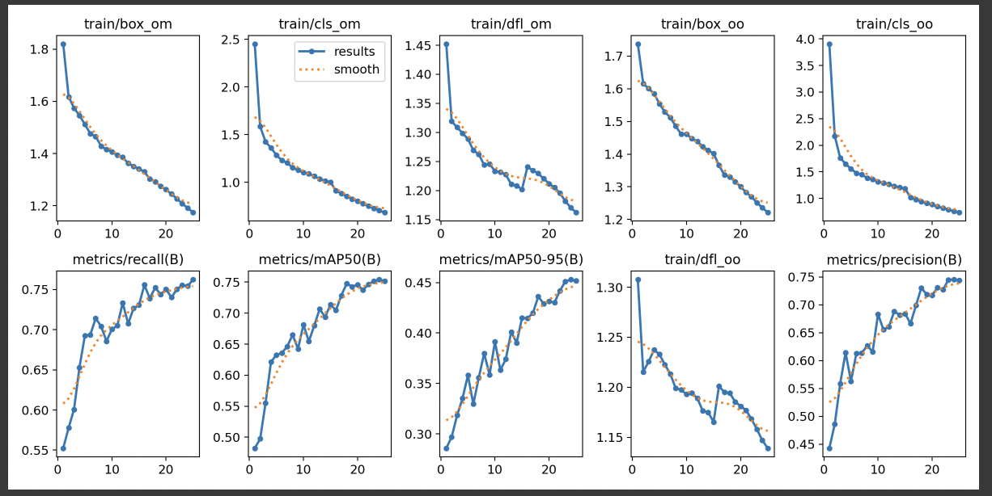

Model Predictions on Validation sets :

Yolov9:

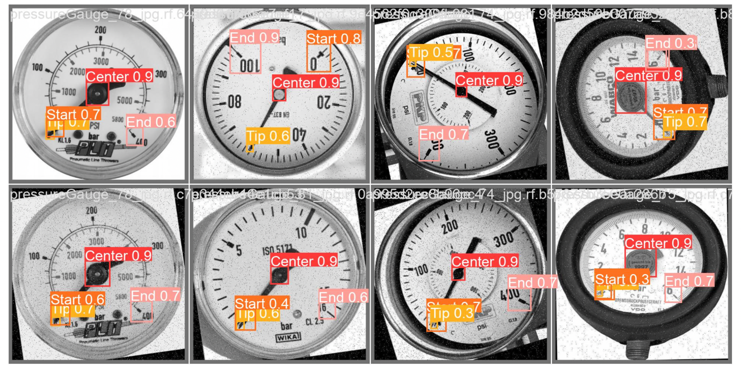  
  
Yolov10:

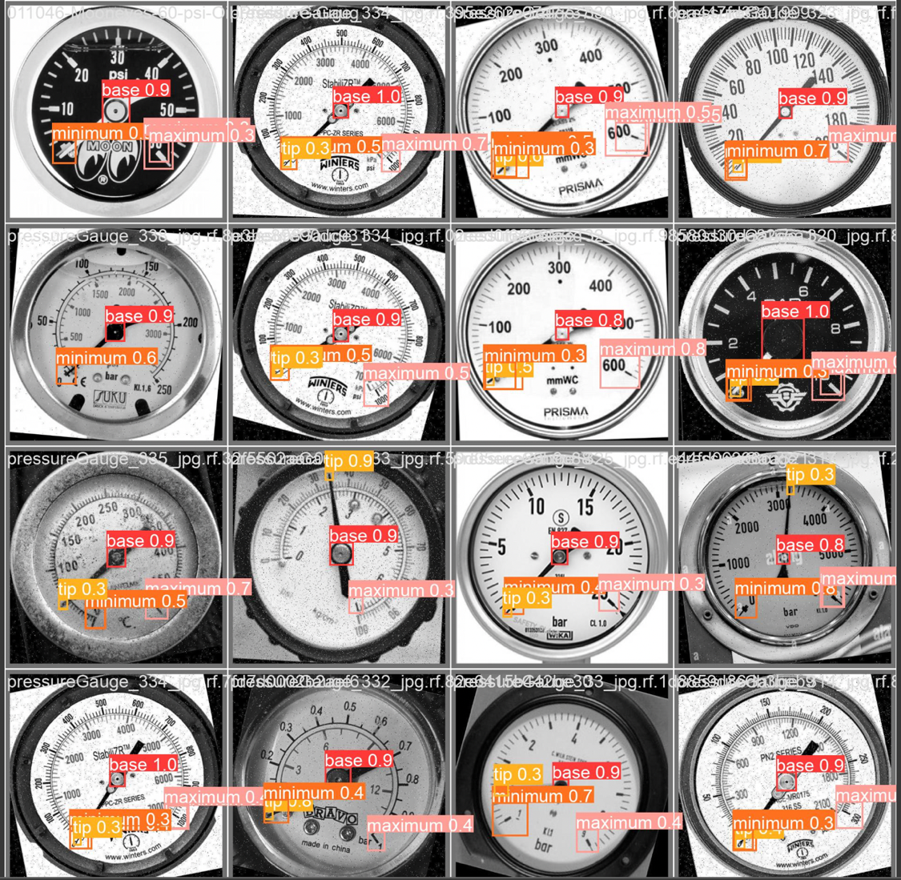

Inference on custom data using live Webcam :  
  
 ** WIP **